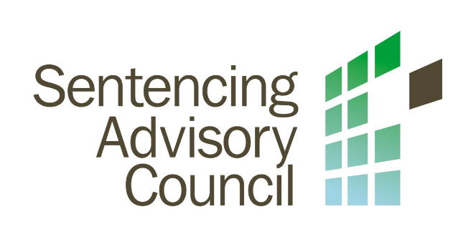

Gifts, Benefits and Hospitality

Policy

Background and purpose
The Sentencing Advisory Council (SAC) is committed to transparency, probity and acting with integrity in keeping with the Victorian Public Sector Code of Conduct. In some situations, whilst fulfilling duties for SAC staff may be offered a gift, benefit or hospitality. The purpose of this policy is to describe how SAC deals with these situations.

Definitions

Gifts a gift is an item of value which one person or organisation provides to another for no, or greatly reduced, cost e.g bottle of wine, commemorative plaques, pens, key rings, mouse pads, books and ticket to event.

Benefits benefits are preferential treatment, privileged access, favours and other advantage offered e.g invitations to sporting, cultural or social events, access to discounts and loyalty programs, and promise of a new job.

Hospitality is the friendly reception and treatment of guests ranging from light refreshment at a business meeting to restaurant meals and sponsored travel and accommodation.

Minimum requirements
The minimum requirements for all SAC staff when it comes to gifts, benefits and hospitalities are:
- do not solicit gifts, benefits or hospitality.
- refuse all offers of gifts, benefits or hospitality that could be reasonably perceived as undermining the integrity and impartiality of SAC, the Department of Justice and Community Safety or the staff member.
- refuse all offers of gifts, benefits or hospitality from people or organisations about whom staff are likely to make decisions involving
- tender processes;
- procurement;
- enforcement;
- licensing; or
- regulation.
- refuse all offers of money or items easily converted to money such as shares.
- refuse bribes and report bribery attempts to the head of the public sector organisation or their delegate, within 14 days, who will decide whether to report to Victoria Police.
- seek advice from a manager or other appropriate organisational delegate if unsure about how to respond to an offer of a gift, benefit or hospitality.

Accepting gifts, benefits and hospitality
Tokens, mementos and small gifts of appreciation such as pens or pads, a box of chocolates or a bottle of wine, handed out at conferences or after presentations may generally be accepted as they are inexpensive and intended to serve as a reminder of the event or as a sign of appreciation for the work done. These gifts are generally offered publicly and declining could cause embarrassment or offence. If these gifts are of nominal value, then they are not a reportable gift.
Modest hospitality such as tea, coffee, finger food or sandwiches offered as a courtesy at a meeting or conference may be accepted. However, in all cases the hospitality should be proportionate to the occasion. Modest hospitality offered as part of official business is not a reportable gift.
Gift vouchers for bookstores may be given to staff members after a presentation. All gifts vouchers are reportable gifts but if they are of a nominal value then the staff member who received the gift, after reporting it, may keep it.
Ceremonial gifts offered from international visitors become the property of SAC and if of a significant value are recorded on the asset register.

Reporting gifts, benefits and hospitality
If a gift, benefit or hospitality is valued at $50 or more, then the staff member receiving or being offered it needs to complete a gifts declaration within 14 days.
A redacted register will be published annually on the SAC website if a gift, benefit or hospitality is added to the register.

